Call for Speakers

PMI Austin Lunch N Learn Speaker Form

Thank you for your interest in speaking at one of our Lunch N Learn meetings. Please keep in mind these are volunteer speaking opportunities for our monthly meetings. PMI has over 3000+ members represented in the following industries: IT, Healthcare, Construction, Public Sector, and Education.
Due to the post COVID-19 pandemic, PMI Austin has transitioned to 100% virtually.
Our virtual Lunch N Learns takes place every 3rd Thursday, from 12:00 pm to 1:00 pm CT via Zoom
Speaker Contact Information (please complete)
Speaker Name
Organization or PMI Chapter | PMI Austin
Today’s Date
Address
Email address
Website
Twitter and LinkedIn:
Phone/Cell Number
YouTube or link to video presentation

Speaker Bio

Previous Speaking Experience
List your most recent speaking experience (maximum 150 words)

Speaker Photo
(please attach to email when submitting form)

Presentation Information (please complete)
Presentation Title
Description of Presentation (Maximum 250 words)
Learning Objectives for Presentation (Minimum 3 SMART Objectives)
Expected Key Takeaways for Participants
Select the Event for your Presentation | ☒ Lunch & Learn
Presentation Category (PMI Talent Triangle)
- Ways of Working (formerly Technical Project management)
- Power Skills (formerly Leadership)
- Business Acumen (formerly Strategic and Business Management)
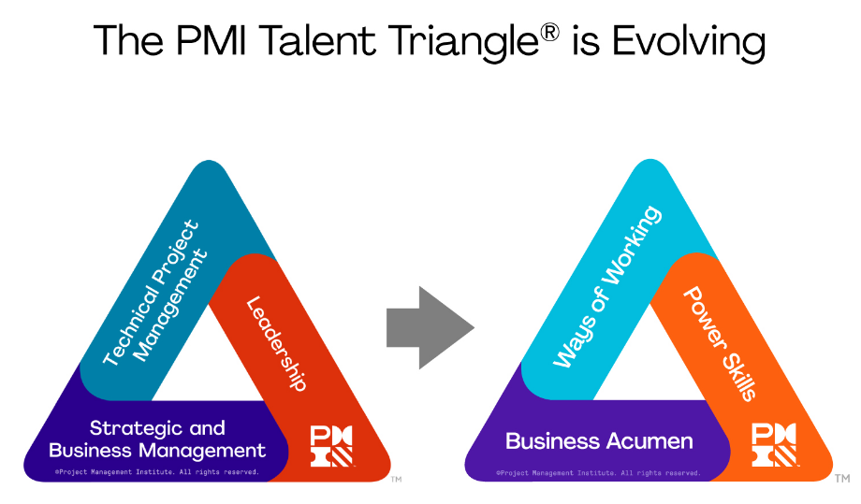
Ways of Working: Whether it’s predictive, agile, design thinking, or new practices still to be developed, it's clear that there is more than one way that work gets done today. That’s why we encourage professionals to master as many ways of working as they can - so they can apply the right technique at the right time, delivering winning results.
Power Skills: These interpersonal skills include collaborative leadership, communication, an innovative mindset, for-purpose orientation, and empathy. Ensuring teams have these skills allows them to maintain influence with a variety of stakeholders - a critical component for making change.
Business Acumen: Professionals with business acumen understand the macro and micro influences in their organization and industry and have the function-specific or domain-specific knowledge to make good decisions. Professionals at all levels need to be able to cultivate effective decision-making and understand how their projects align with the big picture of broader organizational strategy and global trends.

